Office Use Only
Spreadsheet
Thank You Letter
Enter into OneCause
Donation Received
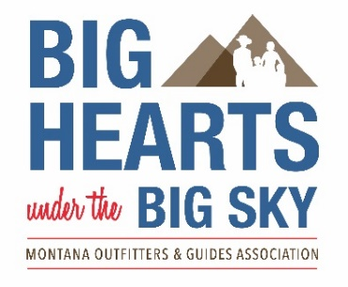

AUCTION DONATION FORM

The Big Hearts under the Big Sky Benefit Auction is April 11, 2026
at The Best Western Premier Helena Great Northern

Business/Individual Name: ________________________________________________________________________
Contact Name: ___________________________________________________________________________________
Address: _______________________________________________________________________________________
City, ST, ZIP: ____________________________________________________________________________________
Phone: __________________________________ Email:_________________________________________________

I intend to donate the same item as last year

I intend to make a monetary donation for the 2025 Event

I will donate the following (Please describe item and include Fair Market Value)
_______________________________________________________________________________________________
_______________________________________________________________________________________________
_______________________________________________________________________________________________
_______________________________________________________________________________________________
_______________________________________________________________________________________________

Fair Market Value: __________________

Please return via email to bighearts@mogamt.org or mail to the address below. Donations can also be mailed to the address below or arrangements can be made for a Big Hearts volunteer to pick up.

Montana Outfitters and Guides Education Institute’s Big Hearts under the Big Sky Program a non-profit organization, is supported by voluntary donations. Thanks for your generous support of the Education Institute, Big Hearts under the Big Sky program EIN 84-1424925. We encourage you to consult your tax adviser as to what amount of your donation may be considered tax deductible.

